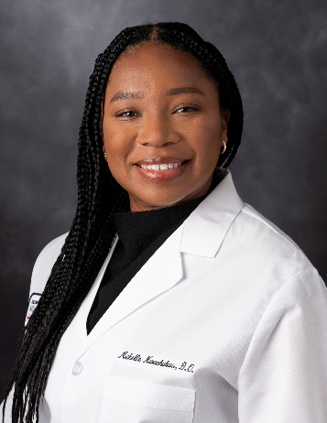 | Michelle Nwachukwu, DO  Leukemia Fellow: MD Anderson Cancer Center  IM Residency: University of Illinois Chicago, IL  Medical School: Arkansas College of Osteopathic Medicine, AR

Michelle Nwachukwu, MBS, DO is a first-year fellow in the Leukemia Fellowship Program at The University of Texas MD Anderson Cancer Center, having joined the program in July 2025. Her academic and clinical interests focus on leukemia and health disparities research, with a commitment to advancing equitable care and outcomes for patients with hematologic malignancies.

Dr. Nwachukwu earned her undergraduate degree from Baylor University and received her Doctor of Osteopathic Medicine from the Arkansas College of Osteopathic Medicine in Fort Smith, Arkansas, in 2022. She was honored with the Hematology Inclusion Pathway Resident Award by the American Society of Hematology in 2024 for her research on health disparities in acute myeloid leukemia.

She completed her residency in Internal Medicine at the University of Illinois Chicago, where she further developed her clinical expertise and research focus.

Outside of her professional responsibilities, Dr. Nwachukwu enjoys attending cultural festivals, exploring music concerts, and is fluent in Spanish.

