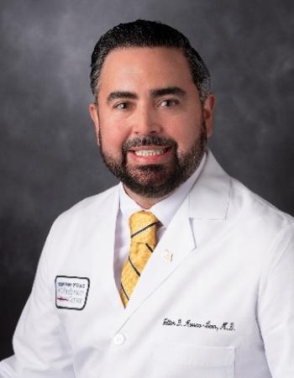 | William D. Marrero-León, MD  Clinical Fellow: Leukemia MDACC  Heme Onc: San Juan City Hospital, Puerto Rico  IM Residency: San Juan City Hospital, Puerto Rico  Medical School: Iberoamerican University School of Medicine, DR

William D. Marrero-León, MD is a first-year fellow in the Leukemia Fellowship Program at The University of Texas MD Anderson Cancer Center, having joined the program in July 2025. His clinical and research interests focus on the development of targeted therapies and the application of molecular markers in the treatment of leukemia. His passion for hematologic malignancies was sparked during his medical internship under the mentorship of Dr. Fernando Cabanillas, during which he contributed to two peer-reviewed publications.

Dr. Marrero earned his medical degree from the Iberoamerican University School of Medicine in Santo Domingo, Dominican Republic. He completed his residency in Internal Medicine at San Juan City Hospital, Puerto Rico Medical Center. Following residency, he served as a faculty member at the University District Hospital at Puerto Rico Medical Center, where he practiced as an Internal Medicine physician in the leukemia unit.

He subsequently completed a Fellowship in Hematology and Medical Oncology at San Juan City Hospital, where he served as Chief Fellow. During his fellowship, he was twice awarded first prize in clinical research at the Puerto Rico Hematology Oncology Convention for his work on molecular and cytogenetic abnormalities in acute myeloid leukemia (AML) patients in Puerto Rico. Dr. Marrero is board-certified in both Internal Medicine and Hematology.

Outside of his professional responsibilities, Dr. Marrero enjoys exploring new cultures and cuisines and spending quality time with his family.

