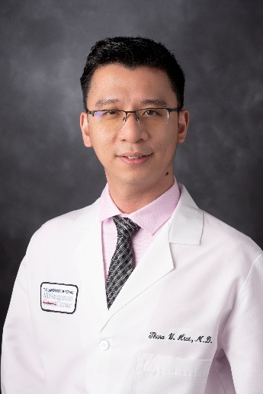 | Thura Win Htut, MD MRCP, FRCPath  Leukemia Fellow: MD Anderson Cancer Center  Heme Onc: Royal College of Pathologists, UK  IM Residency: Royal College of Physicians, UK  Medical School: University of Medicine I, Yangon, Myanmar

Thura Win Htut, MD is a first-year fellow in the Leukemia Fellowship Program at The University of Texas MD Anderson Cancer Center, having joined the program in July 2025. His academic interests include clinical research in myelodysplastic syndromes and acute myeloid leukemia, with a focus on therapeutic outcomes and translational approaches. He is committed to contributing to ongoing research initiatives and developing novel studies within the leukemia program.

Dr. Htut earned his medical degree from the University of Medicine 1, Yangon, in 2012, graduating with honors in medicine, surgery, and pediatrics. He received multiple academic distinctions during his training, including awards in physiology, anatomy, pathology, and microbiology. He completed his internal medicine training at hospitals accredited by the Royal Colleges of Physicians in the United Kingdom and subsequently served as a resident physician at Khoo Teck Puat Hospital in Singapore.

Dr. Htut then pursued five years of combined clinical and laboratory hematology specialty training in the United Kingdom, culminating in 2024. He was awarded the Fellowship of the Royal College of Pathologists (FRCPath) in 2022 and most recently served as a consultant hematologist at Aberdeen Royal Infirmary from 2024 to 2025.

Outside of his clinical and research responsibilities, Dr. Htut enjoys traveling, discovering new cultures, and engaging in lifelong learning.

