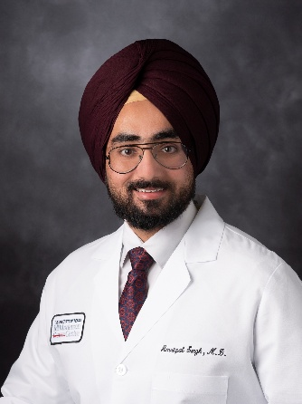 | Amritpal Singh, MD  Leukemia Fellow: UT MD Anderson Cancer Center  IM Residency: Univ. of Colorado Heath, Parkview Medical Center, CO  Medical School: Adesh Institute of Medical Sciences & Research, India

Amritpal Singh, MD is a first-year fellow in the Leukemia Fellowship Program at The University of Texas MD Anderson Cancer Center, having joined the program in July 2025. His clinical and research interests focus on targeted therapies and the application of molecular markers to improve treatment strategies and outcomes for patients with acute leukemia.

Dr. Singh completed his Internal Medicine residency at University of Colorado Health Parkview Medical Center in June 2025 and is board-certified in Internal Medicine. During residency, he served as Research Chief Resident for two years, reflecting a strong commitment to academic medicine and mentorship.

Prior to residency, Dr. Singh completed a one-year research fellowship at Mayo Clinic, Rochester, where his work focused on acute myeloid leukemia and myeloproliferative neoplasms, resulting in multiple peer-reviewed publications. He earned his medical degree from Adesh Institute of Medical Sciences and Research, India.

At MD Anderson, Dr. Singh serves as Secretary of the GME House Senate (2025–2026) during his fellowship, highlighting his continued involvement in graduate medical education and institutional leadership. During his fellowship at MD Anderson, his research has focused on NPM1-mutated acute myeloid leukemia and RAS pathway mutations. He has also received the ASH Abstract Achievement Award at the American Society of Hematology Annual Meeting in 2025.

Outside of his professional responsibilities, Dr. Singh enjoys academic writing, dancing, and exploring diverse cuisines.

