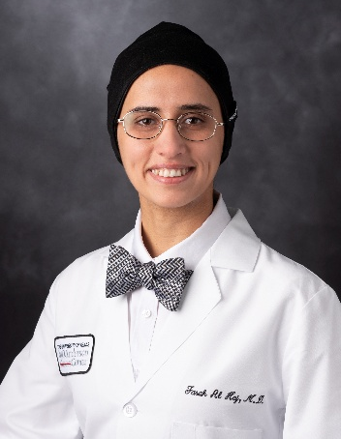 | Farah Al Haj, MD  Leukemia Fellow: MD Anderson Cancer Center  Heme Onc: Tulane University, New Orleans, LA  IM Residency: Sinai Grace Hospital-Detroit Medical Center  Medical School: Hashemite University, Jordan

Farah Al Haj, MD is a first-year fellow in the Leukemia Fellowship Program at The University of Texas MD Anderson Cancer Center, having joined the program in July 2025. Her clinical focus includes leukemia and myeloid disorders, with a commitment to advancing personalized treatment strategies informed by emerging therapies and ongoing clinical trials. She aims to develop the expertise necessary for independent practice upon completion of her fellowship.

Dr. Al Haj earned her Doctor of Medicine degree from the Hashemite University in Jordan in 2017, graduating among the top 8% of her class and receiving honor roll distinction in her final year. She completed her residency in Internal Medicine at Sinai Grace Hospital–Detroit Medical Center/Wayne State University, where she served as class representative during her final year, demonstrating leadership and advocacy for her peers.

Prior to joining MD Anderson, Dr. Al Haj completed a Hematology and Oncology fellowship at Tulane University in New Orleans, Louisiana, in 2025, where she deepened her clinical and research expertise in malignant hematology and solid tumors.

Beyond her professional pursuits, Dr. Al Haj enjoys creative writing, hiking, and nature photography—particularly capturing sunsets. She published a prose poetry book in 2009 during her high school years. Fluent in Arabic, she also has a longstanding passion for soccer, which she continues to enjoy recreationally.

