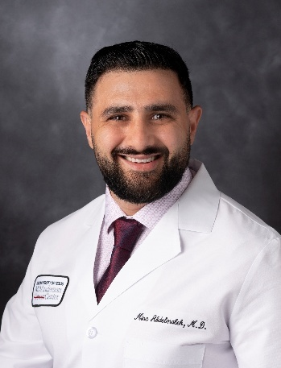 | Mina Abdelmalek, MD  Leukemia Fellow: MD Anderson Cancer Center  IM Residency: The State University of New York at Buffalo  Medical School: Menoufia University in Egypt

Dr. Mina Abdelmalek is a first-year fellow in the Leukemia Fellowship Program at The University of Texas MD Anderson Cancer Center, where he began training in July 2025. His clinical and research interests are centered on hematologic malignancies, and he intends to pursue subspecialty training in hematology and oncology.

Dr. Abdelmalek received his undergraduate education at Menoufia University in Egypt and earned his M.B.B.Ch. from Menoufia University Faculty of Medicine in February 2013, graduating with distinction under a full scholarship. He completed his residency in Internal Medicine at The State University of New York at Buffalo/Catholic Health System from 2020 to 2023, achieving board certification in Internal Medicine in 2023, serving as Chief Resident in his final year.

Dr. Abdelmalek has cultivated a strong foundation in clinical research. He collaborated with Roswell Park Comprehensive Cancer Center on multiple oncology projects between 2021 and 2023, including a study presented at ASH 2022 titled “Gemtuzumab ozogamicin plus standard induction chemotherapy improves outcomes of newly diagnosed intermediate cytogenetic risk acute myeloid leukemia.” From 2023 to 2025, Dr. Abdelmalek practiced as an Internal Medicine Specialist at Memorial Hermann Medical Center in The Woodlands, Texas.

Outside of medicine, Dr. Abdelmalek enjoys spending time with his wife and son, long-distance running—having completed two half marathons and one full marathon—and engaging in recreational activities such as video gaming, Orangetheory Fitness, and soccer. He is fluent in Arabic and English.

